SSJG: Adding a testimonial to ministries:
- Go to the CMS and log in with your username and password.
*If you have forgotten your password, click the “Lost your password?” link and enter your username or email. Then check your email (including your spam/junk folders) for an email from us on how to reset your password.
- Once successfully logged in, you will see the dashboard (see image below). Click on News from the menu (highlighted in yellow on the image).
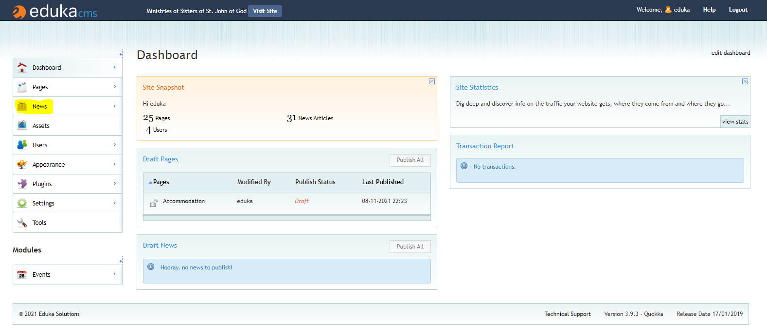
- We use the News view to manage the testimonials (among other things), from this screen you can add/edit/delete/publish news items (see image below). To add a new testimonial we will click the add new button (highlighted in yellow on the image).
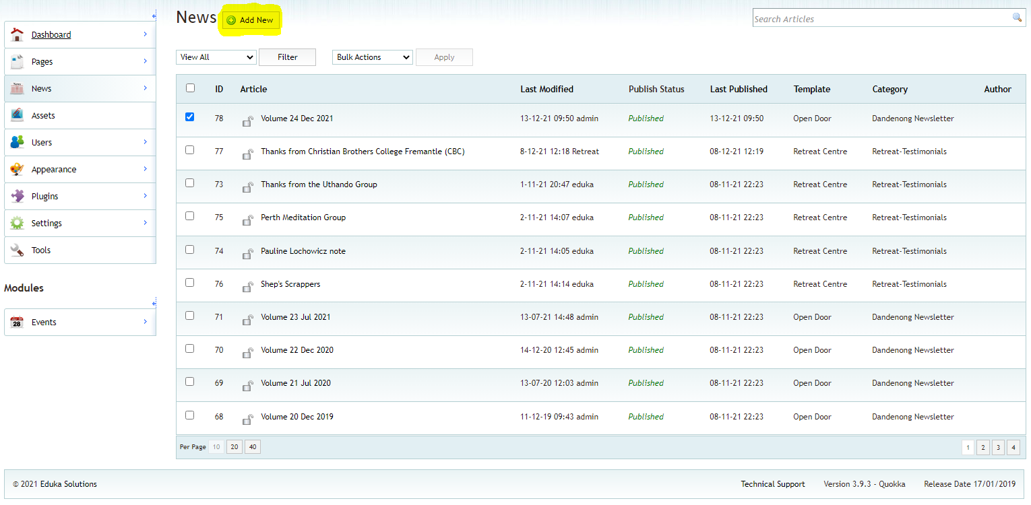
- This will bring you to the Add News page. Follow the steps:
- Step 1 – Select a template: Select Retreat Centre
- Step 2 – Enter a Headline, Title & Summary:
Headline is what the article will be saved as in the CMS (i.e. its name) and, for a regular page, its URL also.
Title is the title of the page/news item. Often this is the same as the headline
Summary will give a description for the link to the testimonial
- Step 3 – Add the Content: Decide if you will at text content or if you will attach a file (like an image) for the testimonial. Then click next.
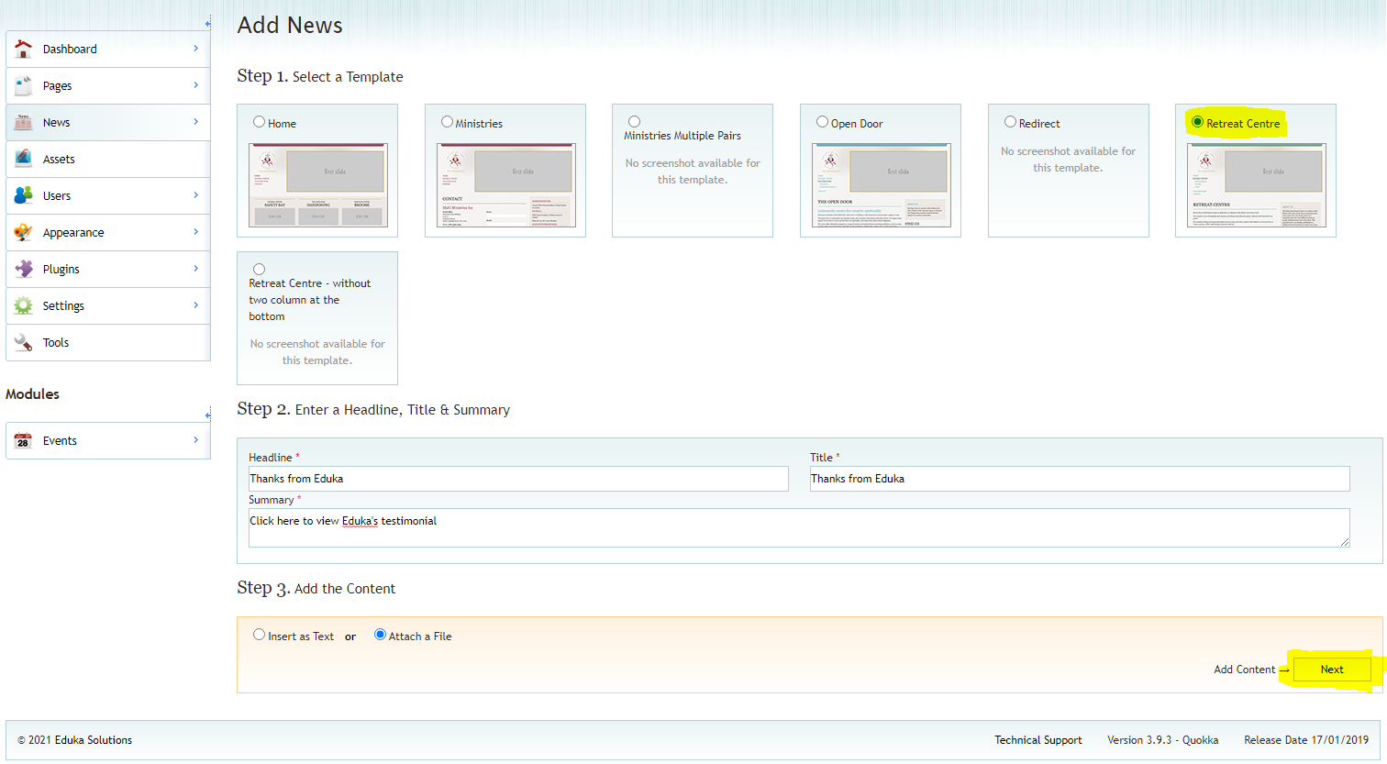
- This will bring you to a final screen where you can edit the details you have added so far (e.g. headline, title, or summary) and where you can add your testimonial from your assets folder. Remember to add a publication date & time and select the category “Retreat-Testimonials” from the Attributes box (in yellow on the image below)
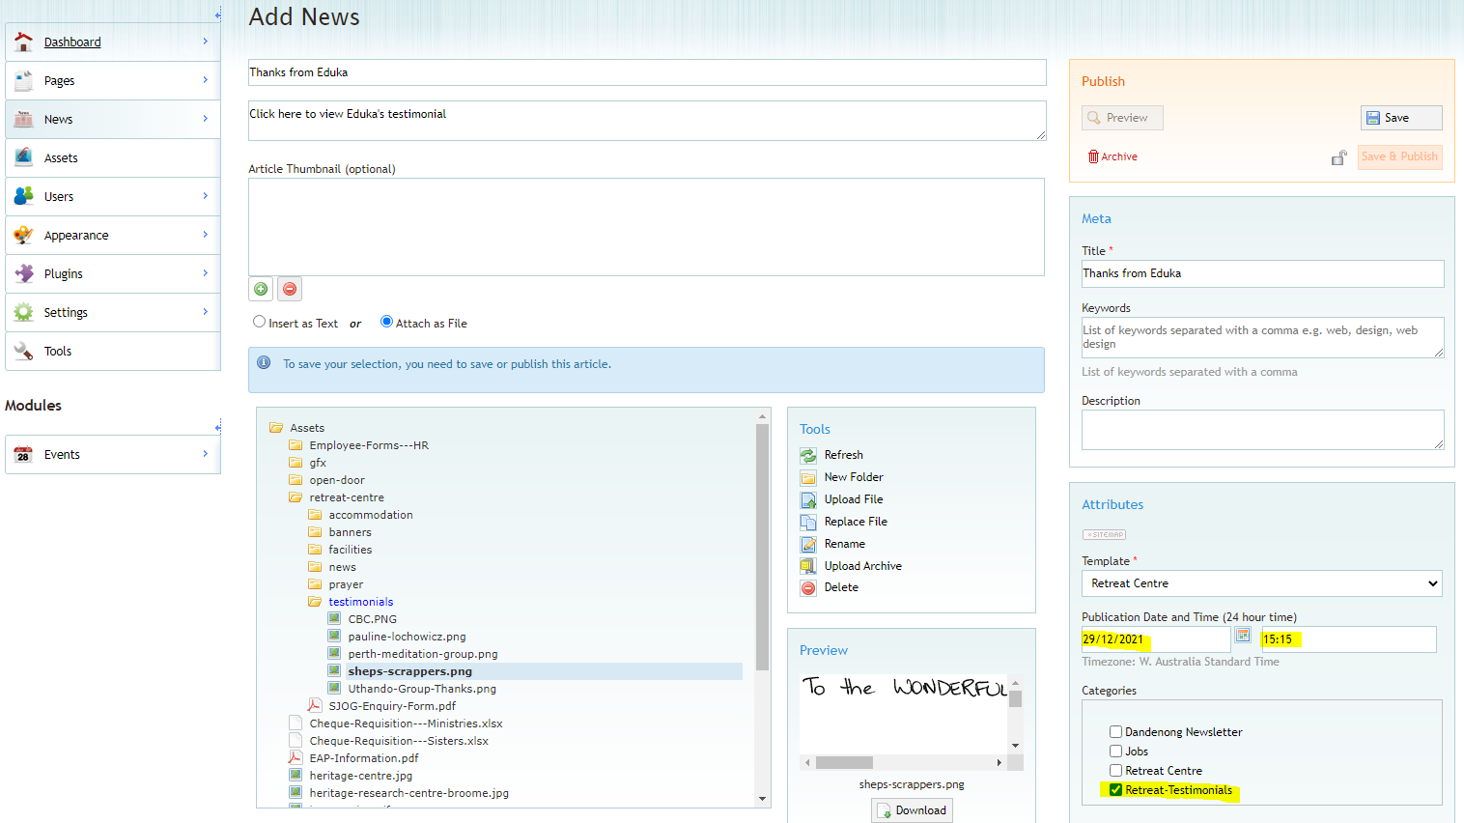
- Finally click “Save” to save your changes (as a draft), and then click “Save & Publish” to publish your new testimonial (i.e. have it visible on the website)
Note You won’t be able to publish if the padlock icon is locked and yellow, or if you haven’t clicked “Save” at least once. If the padlock is shut, simply click on it to unlock it and you will be able to publish.
